Computer Language Coding Concepts

Parameters in a Command Definition in a Diagram
Parameters in a command definition have been conceptually explained in the article Parameters in a Command Definition.

This article only illustrates how parameters in a command definition look in a diagram.
The diagram below displays an inactive command definition with parameters:

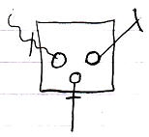

The square is a command definition. It could also have been a diamond, if it was an active command definition. The circles inside of it are the parameters. The rest of what’s visible in the diagram are the parameter passings. Parameter passings are explained in the parameter articles. The parameter passings are the lines connected to the circles, that are marked with an access mark.

See also: Parameters in a Command Definition,
Creation Behavior of Command Calls in a Diagram

Author & Copyright: Jan-Joost van Zon Date: August 9, 2008 – August 12, 2008 Location: Oosterhout, The Netherlands Status: Finished

